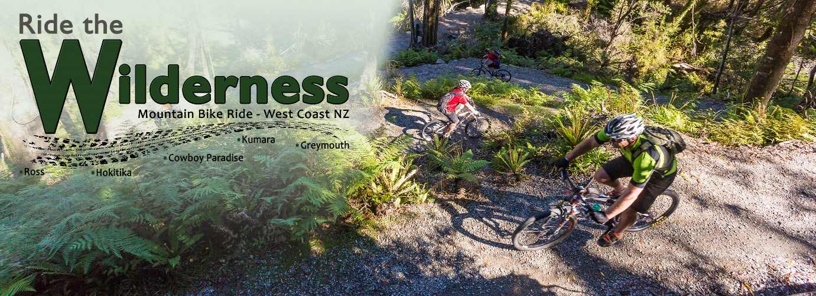

Ride the Wilderness

Communications of the event

Ride the Wilderness is a race on Saturday 17 November 2018, starting at Ross at 8:00am and traveling through to Greymouth. The cut off for riders is 4:00pm at Greymouth.

On the day, there will be 4 events with the following start times that will see numerous cyclists on the trail heading North in what may be a fast pace. All riders on the trail will need to be mindful of this event and the location start times and estimated through times of each location.

Start times:
Ross to Greymouth start 8:00am
Hokitika to Greymouth start time 9:00am
Cowboy Paradise to Greymouth start time 10:00am
Kumara to Greymouth start time 11:00am

We’re anticipating 600+ riders on the day being on the trail and could be upward of 1,000.

Key points of note will be that riders will be heading north on the day and to be aware of the event and the likely number of riders coming towards them in these times and destinations.

We anticipate all riders to be through the following destinations in the following times:
Hokitika by 8:50am – 9:30am
Cowboy Paradise 10:00am – 11:15am
Kumara 11:10am – 2:30pm
Greymouth cut off is 4:00pm

If you have tours or people looking to ride south, it would pay to wait until the estimated times of riders getting though the various points before starting.

If you’re driving out of Cowboy Paradise we ask that this be left until after 11:15am as there will be 3-400 riders coming, up the valley between 9:15 and 11:15am.

Race Pack pickups:
Race pack pick up will be at Monteith’s Brewery on the Friday 16 November between 3:00pm and 6:00pm

Prizegiving:
Prizegiving will be at the Regent Theatre Greymouth at 5:00pm

For more information please go to www.ridethewilderness.co.nz

Thank you

John Moore
Race Director
Ride the Wilderness
CJM’S Events Limited
027 2267769

